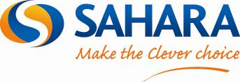

04/03/2013

FOR IMMEDIATE RELEASE

**Contact:** Rob Xenos

**Tel:** 0208 319 7742

**Email:** [rob.xenos@saharaplc.com](mailto:rob.xenos@saharaplc.com)

SAHARA PLC LEADS THE WAY IN THE UK INTERACTIVE FLAT PANEL MARKET

Audio Visual manufacturer and Distributor maintains position as UK market leader

**Sahara Presentation Systems PLC** continues to lead the UK market for Interactive Flat Panel Displays as indicted by Futuresource Consulting in its Education and Corporate Sectors Quarterly Market Track- Quarter 3/4 2012.

**Shaun Marklew**, Sales Director at Sahara says:

“We are delighted to hold the position of market leader in the Education and Corporate Sectors and are dedicated to further developing our product range to offer the very latest in interactive touch technologies. We don’t take this position lightly and are constantly striving to build on our years of knowledge and expertise in the sector.”

If you would like more information about this topic please email [rob.xenos@saharaplc.com](mailto:rob.xenos@saharaplc.com) or visit [www.saharaplc.com](http://www.saharaplc.com)